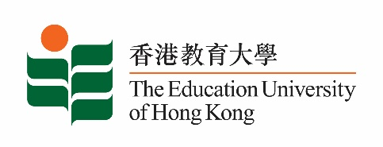

17 April 2025

**致：**  **傳媒機構採訪主任**

**To : News Editors**

**香港教育大學（教大）2025年 4月21至5月4日可供採訪之活動一覽**

**The Education University of Hong Kong (EdUHK) Events Calendar for 21 April – 4 May 2025**

本校誠邀　貴機構派員採訪下列活動。傳媒查詢，請聯絡教大傳訊處（電話：2948 6050）。  
You are cordially invited to cover the events below. For media enquiries, please contact the Communications Office at 2948 6050.

以下活動或有人數限制，傳媒請預先向主辦部門登記。

There may be restrictions on the number of participants for the following event(s). Please contact the respective organiser(s) / department(s) for prior registration.

* **教大大埔校園** （新界大埔露屏路十號）

**EdUHK Tai Po Campus** (10 Lo Ping Road, Tai Po, New Territories)

|  |  |  |  |  |  |
| --- | --- | --- | --- | --- | --- |
| **日期**  **Date** | **時間**  **Time** | **活動**  **Event** | **地點**  **Venue** | **主辦部門及公眾查詢**  **Organiser &**  **Public Enquiry** | **備註**  **Remarks** |
| 2025-04-15  to  2025-04-25 | 1000 – 1900 | 紙上痕迹  Marks on Paper | 新界大埔露屏路10號香港教育大學文化與創意藝術學系展覽廳（B2-P-01）  B2-P-01, CCA Art Gallery, The Education University of Hong Kong, 10 Lo Ping Road, The Education University of Hong Kong, Tai Po, NT | 文化與創意藝術學系 Department of Cultural and Creative Arts  黎先生，Mr Arrow Lai  電話/Tel: 2948 7808 | 免費入場，歡迎各界人士參加。  Free admission.  All are welcome. |